Project Design Phase-II
Technology Stack (Architecture & Stack)

Date | 28 September 2026
Project Name | Metro Ticket Generating System in ServiceNow
Maximum Marks | 4 Marks

Technical Architecture:
The architecture is centered on the ServiceNow cloud platform. The passenger interacts through Service Portal and a Metro Ticket Service Catalog item. UI Policies and limited Catalog Client Scripts control the form experience; fare/station logic determines the ticket amount; Flow Designer orchestrates the booking; a custom Metro Database table stores structured ticket data; and a portal-compatible widget/spModal path presents the QR ticket. Authorized station staff and metro operations users validate and manage booking information.
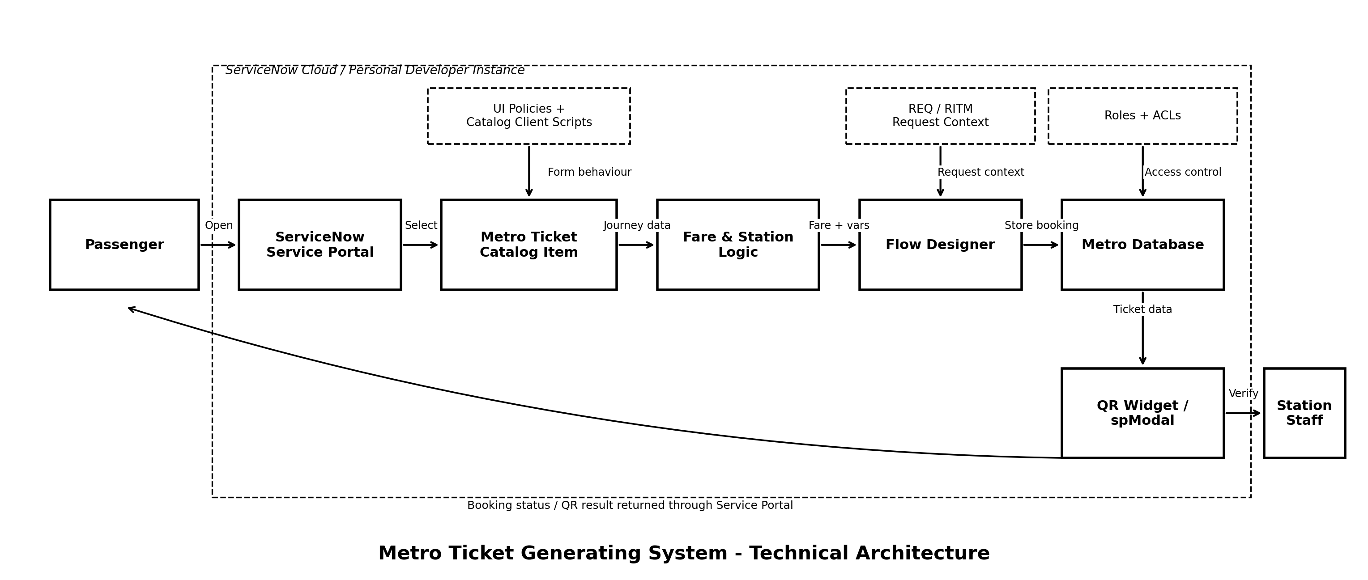
Infrastructure Demarcation
• Cloud / Platform: ServiceNow instance (Personal Developer Instance during development/training).
• Client side: Web browser accessing Service Portal; no separate native mobile application is required for the documented solution.
• Application logic: ServiceNow configuration and low-code automation, primarily Flow Designer, UI Policies, catalog variables and limited Catalog Client Scripts.
• Data storage: ServiceNow request records plus a custom Metro Database table.
• External interfaces: No production payment gateway, SMS, WhatsApp or third-party API is claimed as implemented in the current version.
• Machine learning: Not applicable to the current project.

Table-1: Components & Technologies
S.No | Component | Description | Technology
1 | User Interface | Passenger-facing booking, request tracking and digital ticket experience. | ServiceNow Service Portal; Service Catalog; catalog variables
2 | Application Logic-1 | Dynamic form behaviour and essential client-side population/validation. | ServiceNow UI Policies; Catalog Client Scripts (minimal use)
3 | Application Logic-2 | Fare calculation and station mapping used to determine journey fare. | Configured ServiceNow logic / scripts used in the project; station/fare mapping
4 | Application Logic-3 | End-to-end request processing and automation. | ServiceNow Flow Designer; conditions; actions; dynamic task creation
5 | Ticket Presentation | Portal-compatible display of the digital ticket / QR result. | Service Portal widget architecture; spModal; QR rendering logic
6 | Database | Structured ticket / booking information. | ServiceNow custom table: Metro Database
7 | Platform Records | Native request context created from Service Catalog submission. | ServiceNow Request / Requested Item (REQ / RITM) records
8 | Notifications | Configured request / workflow notifications where used. | ServiceNow Notifications / Flow Designer notification actions
9 | Security | Role-based protection of records and operations. | ServiceNow Roles and Access Control Lists (ACLs)
10 | Diagnostics | Trace automation, variable values and failures. | Flow Designer Execution Details; platform logs / debugging outputs used during development
11 | File Storage | No independent application file-storage service is required by the documented core flow. | ServiceNow-managed platform storage as applicable; no separate storage service specified
12 | External API / Payment | Future integration point for payments or messaging. | Not implemented in current version; future UPI/payment/SMS/email/WhatsApp integrations
13 | Machine Learning Model | No ML inference or model dependency is part of the current solution. | Not applicable
14 | Infrastructure (Server / Cloud) | Application deployment and execution environment. | ServiceNow cloud instance / Personal Developer Instance for development

Technology Flow
Browser -> Service Portal -> Metro Ticket Catalog Item -> UI Policies / Catalog Client Scripts -> Fare & Station Logic -> Flow Designer -> REQ/RITM + Metro Database -> QR Widget/spModal -> Passenger / Station Validation.

Table-2: Application Characteristics
S.No | Characteristics | Description | Technology / Design Choice
1 | Open-Source Frameworks | No separate open-source application framework is required by the documented core implementation. QR generation may use code/library logic, but the supplied project description does not identify a specific library. | ServiceNow platform components; specific external QR library not asserted
2 | Security Implementations | Protect booking records and administrative capabilities according to user role; enforce controlled read/write access. | ServiceNow roles, ACLs, platform authentication/session controls
3 | Scalable Architecture | Configuration-driven design permits more stations, fare mappings, passenger types and ticket records to be added without replacing the complete solution. | ServiceNow multi-tier SaaS platform + modular Service Catalog / Flow Designer / custom table design
4 | Availability | Application availability follows the availability of the deployed ServiceNow instance and related platform services. The project does not introduce a separate availability layer. | ServiceNow-managed cloud platform; no custom load balancer or distributed server configured by the project
5 | Performance | Minimize unnecessary client scripting and use Flow Designer for maintainable automation. Test fare calculation, variable mapping and QR rendering for normal booking use cases. | ServiceNow server-side workflow execution + lightweight portal/client configuration
6 | Maintainability | Use low-code/configuration-first components and document setup so another administrator can reproduce or modify the solution. | Service Catalog, Flow Designer, UI Policies, ACLs, documented configuration sequence
7 | Observability / Troubleshooting | Trace workflow runs, condition paths and mappings when failures occur. | Flow Designer Execution Details; platform logs/debug outputs
8 | Compatibility | Ensure the QR/ticket experience works in Service Portal rather than relying on backend-only UI behaviour. | Service Portal widget + spModal-compatible presentation

Implemented vs Future Technology Boundary
• Implemented/documented core: Service Portal, Service Catalog, catalog variables, UI Policies, limited Catalog Client Scripts, fare/station logic, Flow Designer, custom Metro Database table, REQ/RITM context, QR display via widget/spModal, ACL/role configuration, testing and execution tracing.
• Future integrations: payment gateway/UPI, SMS ticketing, email ticket delivery, WhatsApp booking/delivery and travel analytics dashboard.
• Not applicable in the current version: machine-learning model and a separately managed application server/database outside ServiceNow.

